**WEEK 6 HANDS-ON:**

**EXERCISE-1:**

APP.JS:

import logo from './logo.svg';

import './App.css';

function App() {

  return (

    <center>

    <h1>Welcome to the first session of React.</h1></center>

  );

}

export default App;

OUTPUT:

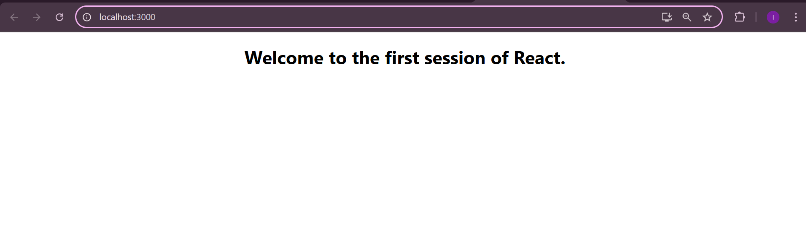

**EXERCISE-2:**

HOME.JS:

import React from 'react'

export default function Home() {

  return (

    <h3>Welcome to the Home page of Student Management Portal</h3>

  )

}

ABOUT.JS

import React from 'react'

export default function About() {

  return (

    <h3>Welcome to the About page of the Student Management Portal</h3>

  )

}

CONTACT.JS

import React from 'react'

export default function Contact() {

  return (

    <h3>Welcome to the Contact page of the Student Management Portal</h3>

  )

}

APP.JS

import './App.css';

import Home from './components/Home';

import About from './components/About';

import Contact from './components/Contact';

function App() {

  return (

    <div className="App">

      <Home/>

      <About/>

      <Contact/>

    </div>

  );

}

export default App;

OUTPUT:

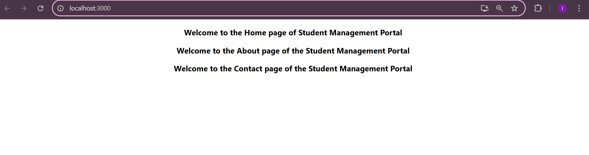

**EXERCISE 3:**

CALCULATESCORE.JS:

import './Stylesheets/mystyle.css'

const percentToDecimal = (decimal) => {

  return (decimal ).toFixed(2) + '%';

};

const calcScore = (total, goal) => {

  return percentToDecimal(total / goal);

};

export const CalculateScore = ({ Name, School, total, goal }) => {

  return (

    <div className="formatstyle">

      <h1 style={{ color: 'brown' }}>Student Details:</h1>

      <div className="Name">

        <b><span>Name: </span></b>

        <span>{Name}</span>

      </div>

      <div className="School">

        <b><span>School: </span></b>

        <span>{School}</span>

      </div>

      <div className="Total">

        <b><span>Total: </span></b>

        <span>{total}</span>

        <span> Marks</span>

      </div>

      <div className="Score">

        <b>Score: </b>

        <span>{calcScore(total, goal)}</span>

      </div>

    </div>

  );

};

MYSTYLE.CSS:

.Name {

  font-weight: 300;

  color: blue;

}

.School {

  color: crimson;

}

.Total {

  color: darkmagenta;

}

.Score {

  color: forestgreen;

}

.formatstyle {

  text-align: center;

  font-size: large;

}

APP.JS:

import { CalculateScore } from '../src/components/CalculateScore';

function App() {

  return (

    <div>

      <CalculateScore

        Name={"Steve"}

        School={"DAV Public School"}

        total={286}

        goal={3}

      />

    </div>

  );

}

export default App;

OUTPUT:

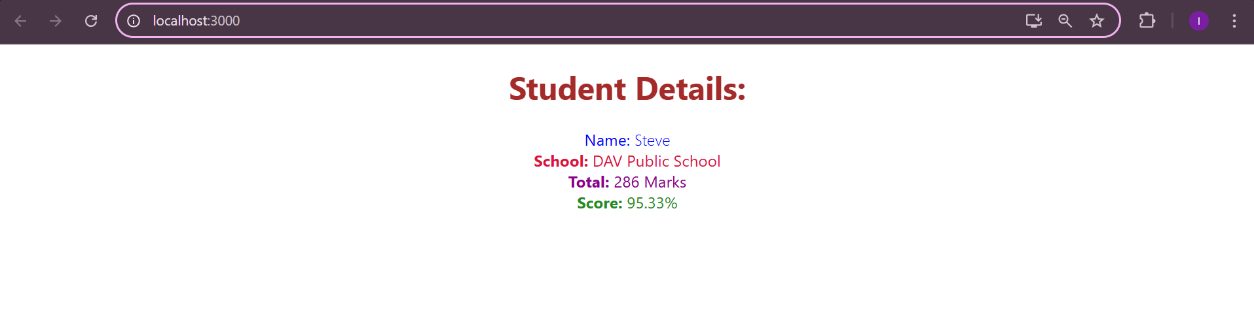

**EXERCISE 4:**

POST.JS:

class Post {

  constructor(id, title, body) {

    this.id = id;

    this.title = title;

    this.body = body;

  }

}

export default Post;

POSTS.JS

import React from 'react';

import Post from './Post';

class Posts extends React.Component {

  constructor(props) {

    super(props);

    this.state = {

      posts: [],

      hasError: false,

      errorInfo: null

    };

  }

  loadPosts() {

    const post1 = new Post(1, 'First Post', 'This is the body of the first post');

    const post2 = new Post(2, 'Second Post', 'This is the body of the second post');

    this.setState({ posts: [post1, post2] });

  }

  componentDidMount() {

    this.loadPosts();

  }

  componentDidCatch(error, info) {

    this.setState({

      hasError: true,

      errorInfo: info

    });

    console.error("Error caught in Posts component:", error, info);

  }

  render() {

    const { hasError, errorInfo, posts } = this.state;

    if (hasError) {

      return <h2>Something went wrong. {errorInfo?.componentStack}</h2>;

    }

    return (

      <div>

        <h1>All Posts</h1>

        {posts.map(post => (

          <div key={post.id} style={{ border: '1px solid gray', margin: '10px', padding: '10px' }}>

            <h2>{post.title}</h2>

            <p>{post.body}</p>

          </div>

        ))}

      </div>

    );

  }

}

export default Posts;

APP.JS

import logo from './logo.svg';

import './App.css';

import Posts from './Posts.js';

function App() {

  return (

    <div className="App">

     <Posts/>

    </div>

  );

}

export default App;

OUTPUT:

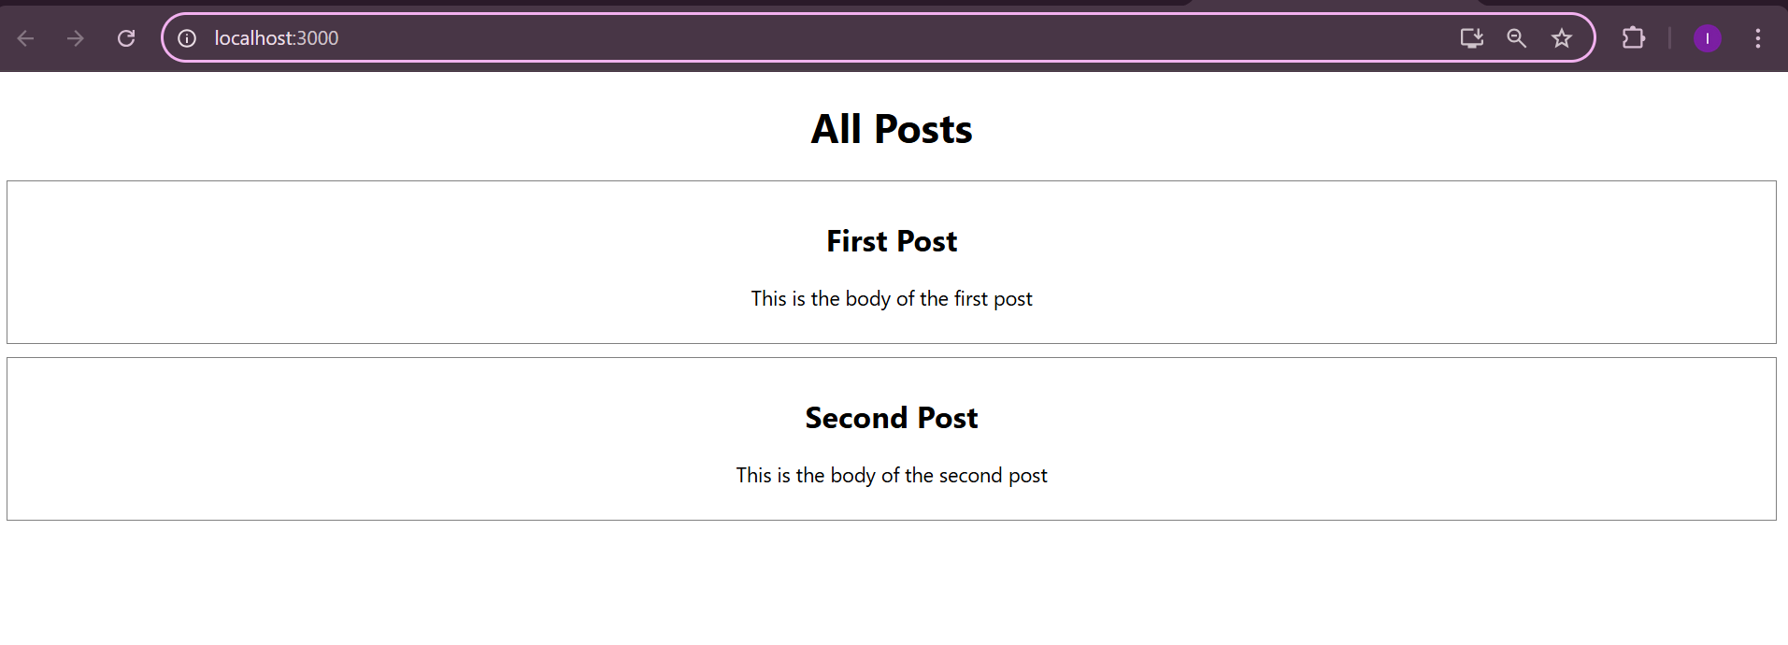

**EXERCISE 5:**

COHORTDETAILS.MODULE.CSS:

.box {

  width: 300px;

  display: inline-block;

  margin: 10px;

  padding: 10px 20px;

  border: 1px solid black;

  border-radius: 10px;

}

dt {

  font-weight: 500;

}

COHORTDETAILS.JS

import styles from './CohortDetails.module.css';

function CohortDetails(props) {

    const { cohortCode, technology, startDate, currentStatus, coachName, trainerName } = props.cohort;

    return (

        <div

            className={styles.box}

            style={{

                width: '300px',

                display: 'inline-block',

                margin: '10px',

                border: '2px solid #ccc',

                verticalAlign: 'top'

            }}

        >

            <h3 style={{ color: currentStatus.toLowerCase() === 'ongoing' ? 'green' : 'blue', fontWeight: 'bold' }}>

                {cohortCode} - {technology}

            </h3>

            <p><strong>Started On</strong><br />{startDate}</p>

            <p><strong>Current Status</strong><br />{currentStatus}</p>

            <p><strong>Coach</strong><br />{coachName}</p>

            <p><strong>Trainer</strong><br />{trainerName}</p>

        </div>

    );

}

export default CohortDetails;

OUTPUT:

